**Class 5 - Content – Spontaneous talks**

Objective – taking part into spontaneous talks.

Problem 1: In pairs or groups of 3, you have to search for texts related to the following topics or choose other ones. Then, you have to create a podcast and present it to the class. The other groups need to listen and comment about what was presented. (2.5 pontos)



(from <https://www.istockphoto.com/br/search/2/image-film?phrase=student+listening+to+podcast>)

Here we have a list of possible themes but you can search for another one:

1-Artificial intelligence.

2- Creativity.

3- Environment.

4- Cybersecurity.

5- Climate change.

6- Veganism.

7- Mental health.

Before you start preparing your podcast, you are going to study a language structure which can be used during your talks.

1-Language structure – You have to start understanding the use of the present perfect tense. To do that, you can read and study the explanation that follows and check understanding with the teacher; you can also watch the following video class or/and search for another video about this grammar topic on the Internet.

<https://www.youtube.com/watch?v=o1_0Gz4uRKo> (very simple way to learn)

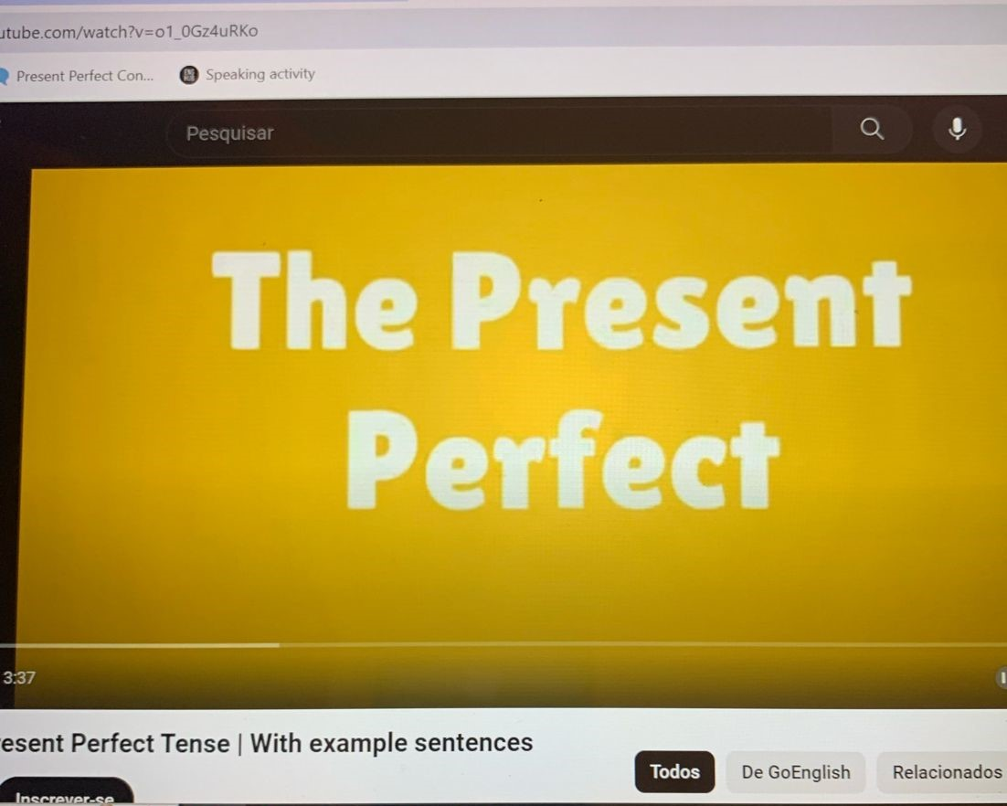

**PRESENT PERFECT TENSE – FORM**

|  |  |  |  |
| --- | --- | --- | --- |
| POSITIVE SENTENCES | | | |
| SUBJECT | AUXILIAR VERB | VERB PAST  PARTICIPLE | COMPLEMENT |
| I  You  We  They | HAVE / ‘VE | WORKED | in a big company for five years |
| He  She  It | HAS / ‘S | DONE | the activity very well. |

|  |  |  |  |
| --- | --- | --- | --- |
| INTERROGATIVE SENTENCES | | | |
| AUXILIAR VERB | SUBJECT | VERB PAST  PARTICIPLE | COMPLEMENT |
| HAVE | I  You  We  They | WORKED | in a big company for five years? |
| HAS | He  She  It | DONE | the activity very well? |

|  |  |  |  |
| --- | --- | --- | --- |
| NEGATIVE SENTENCES | | | |
| SUBJECT | AUXILIAR VERB + NOT | VERB PAST  PARTICIPLE | COMPLEMENT |
| I  You  We  They | HAVE NOT / HAVEN’T | WORKED | in a big company for five years |
| He  She  It | HAS NOT / HASN’T | DONE | the activity very well. |

**PRESENT PERFECT TENSE - USE**

|  |
| --- |
|  |
|  |
| 1-When we talk or ask about things that have happened in the past, but we don’t say when.  Ex.: I HAVE SEEN Harry Potter many times.  My friend is a writer. He HAS WRITTEN many books. |
| 2- When we talk about something that has recently happened.  Ex.: Are you hungry?  No, I’VE JUST HAD dinner. |
| 3- when we discuss events that have been happening over a period of time but aren’t finished yet.  Ex.: I HAVE WORKED at Fatec for eight years. |
| 4- With “ever” (at any time in your life) and “never” (at no time in your life.  Ex.: HAVE YOU EVER BEEN to the USA?  My sister HAS NEVER TRAVELLEDby plane. |
| 5- With “already” (before you/I expected) e “yet” (until now).  Ex.: It’s only 9:00 and Anna HAS ALREADY GONE to bed. (before I expected)  Diane and Paul HAVEN’T ARRIVED yet. |
| 6- With “for” (a period of time) and “since” (the start of the period)  Ex.: Richard HAS BEEN in Canada for six months.  Richard HAS BEEN in Canada since January. |

Class 6 - Content – Spontaneous talks

Objective – taking part into spontaneous talks.

2 – Exercises – Do these exercises about present perfect.

2.1 – A customer service manager is talking about the situation in his department. Complete the text with the present perfect form of the verbs in brackets. (Business Result, Pre-intermediate, OUP, page111)

This month ____________________ (be) a very good one for me. Three more members of my team _____________________ (tell) me that they are leaving the company. Two of them ___________________________ (not / find) another job yet, but they say that the pressure of work ___________________________ (become) too much for them. It’s true that there ______________________ (be) a big increase in their work this year because two other customer service assistants _________________________ (already / leave) the department and we ______________________ (not / recruit) anybody to replace them. I _____________________ (ask) my boss several times if we can employ some new people for the team, but each time he ________________________ (say) that we need to reduce our salary costs. But I know we ________________________ (lose) some business because we ________________________ (not / have) enough people to deal with customer calls.

The situation can’t continue like this. I _________________________ (not / make) a final decision on this yet, but I’m thinking of leaving the company myself.

2.2 – Put the verbs in parentheses in the present perfect or simple past. (American English File 1, OUP, page 147)

A: _____________ you ever ________________ abroad? (travel)

B: Yes, I ____________________ to Peru last year. (go)

A: ______________ you ever ________________ any countries in Asia? (visit)

B: Yes, I _______________. I _________________ to South Korea a few years ago. (go)

A: Who ________________ you ________________ with? (go)

B: My husband. It was a work trip and his company _________________ for everything. (pay)

A: How wonderful! How ____________ you _______________ there? (get)

B: We __________________. (fly)

A: Where ______________ you ________________? (stay)

B: We ___________________ a suite in a five-star hotel. It was beautiful! (have)

A: ________________ the company ________________ you on any other trips recently? (take)

B: No. My husband ____________________ working there a year later, so that was our only trip. (stop)

A: Too bad!

2.3 – Do these online exercises.

<https://www.englisch-hilfen.de/en/exercises/tenses/present_perfect_statements.htm>

<https://www.english-4u.de/en/tenses-exercises/present-perfect-questions3.htm>

<https://www.english-4u.de/en/tenses-exercises/for-since2.htm>

<https://test-english.com/grammar-points/a2/present-perfect/3/>

Class 7 - Content – Spontaneous talks

Objective – taking part into spontaneous talks.

3 – Speaking - Ask and answer these questions:



(from <https://www.forbes.com/sites/rodgerdeanduncan/2023/11/14/expert-tips-to-master-the-art-of-spontaneous-speaking/>)

1 - Where is the best place you have ever been?

2 - Who is the greatest person you have ever met?

3 - How long have you studied English?

4 - Have you ever given a public speech? What was it? Where?

5 - Have you ever received a gift you hated? What was it? Who gave it to you?

6 - What online game have you played recently?

7 - Have you ever watched a movie/series in English without subtitles? What was the movie/series?

8 - What is the longest time you have stayed surfing the internet?

9 - What is the farthest away from home you have travelled?

10 - How long have you had your cell phone?

11 - How long have you had your present job?

12 - How long have you lived in your house?

13 - Who has helped you a lot in your life?

14 - How many times have you checked your phone today?

15 - What is something you've done this week that you're proud of?

16 - What's the coldest temperature you've ever experienced?

3.1 - Ask and answer these questions using the correct form of present perfect and simple past.

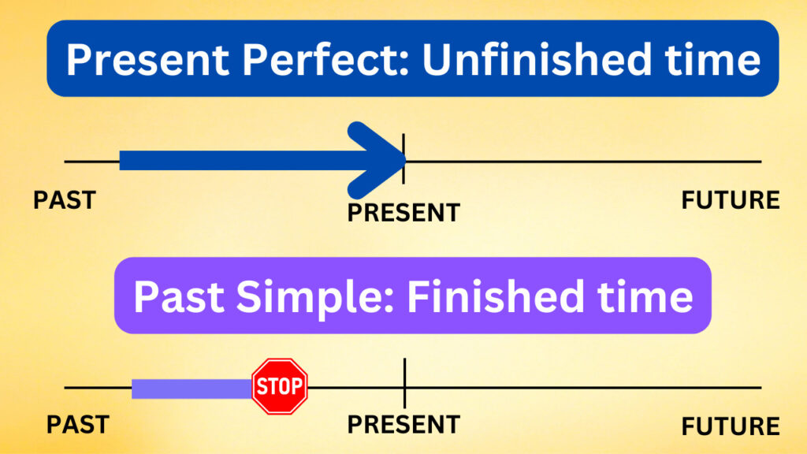

(from <https://www.espressoenglish.net/present-perfect-or-past-simple/>)

1-Have you ever had any problems with your boss? What was the problem? How did you solve it?

2-Why did you choose your present career?

3-Why did you leave your last job?

4-What have you enjoyed the most in your present job?

5-What have you learnt in your present job?

6- Have you ever studied a foreign language? Which language did you study? Why did you start learning it?

7- Have you ever forgotten an important date? What date was it? What happened?

8-Have you ever been to a very hot city? Which city was it? Did you like it? What did you do there?

9-Have you ever been to a College congress? What was the congress about? Did you like it?

10-Have you ever chatted or talked to an English native speaker? Who was the person? What did you talk about? Did you have difficulty in understanding it?

Class 8 - Content – Spontaneous talks

Objective – taking part into spontaneous talks.

4 – Speaking – prepare the activity suggested in problem 1.



(from <https://www.freepik.com/free-photo/multi-ethnic-group-young-men-women-studying-indoors>)

Class 9 - Content – Spontaneous talks

Objective – taking part into spontaneous talks.

5 – Oral presentation – presentation of the podcast suggested in problem 1. (2,5 pontos)



(from <https://www.freepik.com/free-photos-vectors/group-presentation>)